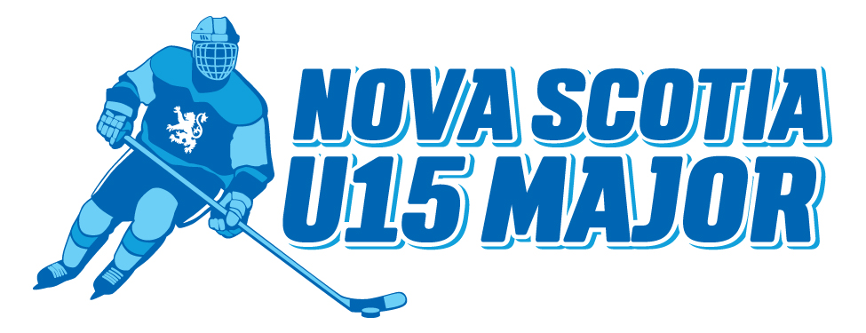

NS U15 Major Hockey League
Fall Tryout Schedule

Checking camps, W/O August 9th
Tryouts open August 16th
August 23rd, down to 30 players
August 30th, down to 25 players
September 6th, 13 plus 1 down to 22
Early Bird tournament, September 11th and 12th
September 13th, final submissions. 48 hours to add but no deletions.
All rosters locked September 16th at 8am.
League play starts September 18th

